Supplementary material of the article “Modeling soil-plant functioning of intercrops using comprehensive and generic formalisms implemented in the STICS model”

Rémi Vezya,b,*, Sebastian Munzc, Noémie Gaudiod, Marie Launaye, Patrice Lecharpentiere, Dominique Ripochee, Eric Justesf

1. CIRAD, UMR AMAP, F-34398 Montpellier, France.
2. AMAP, Univ Montpellier, CIRAD, CNRS, INRAE, IRD, Montpellier, France.
3. Institute of Crop Science, Agronomy, University of Hohenheim, 70599 Stuttgart, Germany
4. INRAE, AGIR, University of Toulouse, Castanet-Tolosan, France
5. INRAE, US1116 AgroClim, Avignon Cedex 9 France
6. CIRAD, Persyst Department, F-34398 Montpellier, France

*Corresponding author. Email address: remi.vezy@cirad.fr (Rémi Vezy, orcid: 0000-0002-0808-1461).

# Model improvements of STICS and description of new formalisms

## Light interception

### Radiative transfer

The radiative transfer option (Brisson et al. 2004) is a module corresponding to a simplified version (pseudo 3D module compatible with the 1D STICS model) of a more complex 3D projection of the crop with homogeneous structure within the row (Figure A1), a formalism found relevant to simulate the light capture and sharing dynamics between the two components/species (or variety) of the bi-specific intercrop. In order to encompass light interception by heterogeneous canopies, STICS implements a geometrical formalism called “radiative transfer” where each species is described by a geometric shape, using 3 options of i) upward triangle, ii) downward triangle, or iii) rectangle (Figure A1).

The dimensions of the crops are computed using the total crop height, canopy base height, and a ratio between the height and width. The spatial design is then determined using the crop shape and the inter-row spacing between the two species simulated. The light intercepted by the two crops associated is computed as the total incoming radiation from the sky minus the radiation transmitted to the soil (Brisson et al. 2004, 2008). The transmitted light is computed over 200 sample points evenly spaced on the ground surface from the plant on the left-hand side until the centre of the inter-row, *i.e.* one half of the inter-row. Direct and diffuse light from the sky are then computed separately. Direct light uses the average position of the sun in the sky throughout the day, and diffuse light is computed by discretizing the hemisphere centred on the point into 46 evenly distributed angles. The dimension along the row is considered infinite. For each angle between the origin of direct or diffuse light and each sample point on the ground, it is tested whether its direction is pointing above or below the crown height in the 3D space. The angles pointing above the crown receive direct and diffuse light directly from the sky. The resulting sky view angle is then used to compute the proportion of direct light effectively intercepted by a point *p* ($K_{dir}$), or the cumulative proportion of diffuse light ($K_{dif}$) received on a given direction using the standard overcast sky (Brisson et al. 2004).

|  |  |
| --- | --- |
| $$R_{dir,p}=R_{dir}∙ K_{dir}$$ | (1) |
| $$R_{dif,p}=R_{dif}∙ K_{dif}$$ | (2) |

where $R_{dir}$ and (MJ m-2 d-1) are the incoming radiation from the sky for direct and diffuse light, respectively, and $K_{dir}$ and $K_{dif}$ are the proportions of direct and diffuse light effectively intercepted by a point *p*.

The light transmitted to the point (${Rt}_{p}$) from the crop canopy is then:

|  |  |
| --- | --- |
| $${Rt}_{p}=\left(1-R_{dir,p}- R_{dif,p}\right)∙e^{-k∙LAI}$$ | (3) |

where $k$ is the canopy light extinction coefficient and $LAI$ the leaf area index (m2 m-2).

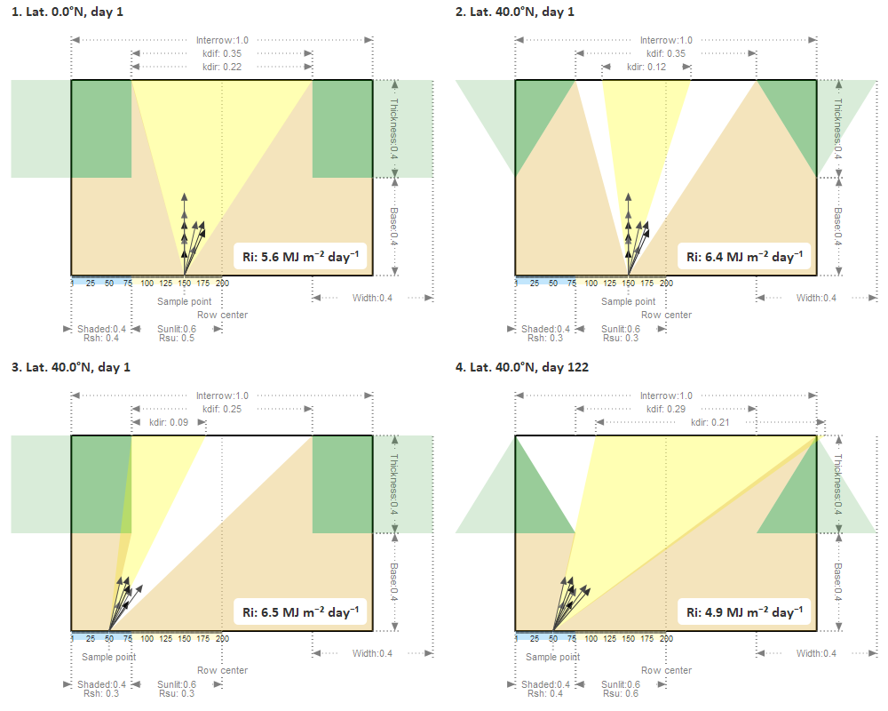

Figure A1. Diagram of the light interception computation using the radiative transfer option with a global radiation of 20 MJ m⁻² d⁻¹, LAI of 2.0, light extinction coefficient of 0.8, and North-South orientation. Panels 1 to 4 illustrate simulations with different canopy shapes (rectangle, downward and upward triangle), latitudes (0 and 40° N) or day of year (1 and 122). Green shapes stands for canopy shape, yellow shape for direct light, white for the diffuse light, black arrows for point directions receiving diffuse light from the sky, and light brown shapes for light transmitted through the crop canopy. Note that diffuse and direct angles may appear pointing towards the crop canopy instead of the sky due to the 3D projection on the 2D space. Ri: radiation intercepted by the crop, Rsh: average radiation ratio received by the sample points in the shaded part (light blue), and Rsu: in the sunlit part (light yellow). Distances are in meter. Note: It may appear counterintuitive that panel 2 intercepts more light than 1 that is at the equator (or 3 in winter more than 4 in spring). The reason is that we compare both with the same incoming radiation, and the projected surface of the crop is higher under lower sun elevation. For more details about this algorithm, see the notebook available at <https://vezy.github.io/STICS-IC-paper>.

The total light intercepted by each point (${Rt}_{p}+R_{dir,p}+R_{dif,p}$) is then averaged over all points from two distinct surfaces: the ground surface directly below the vegetation, called the shaded surface, and the ground surface in-between the vegetation and the centre of the inter-row, called the sunlit surface. Finally, the light intercepted by each crop of the specific intercrop can be computed as the incoming radiation coming from the atmosphere minus the light intercepted in average by the shaded and sunlit surfaces of the ground.

In the case of bi-specific intercrops, the same computation for light interception is applied iteratively for each crop using only the transmitted light as a medium, without any explicit knowledge of the shape of the other crop. This computation is calculated daily and the dominance between the two crops can be inversed over the crop cycle. The sample points are positioned on top of the dominated crop (*i.e.* the smallest crop) instead of the ground for computing the light interception of the dominant crop, and on the ground surface for the dominated crop. The dominated crop is divided into a shaded and a sunlit compartment that are simulated independently, with the only difference being the incoming global radiation, either coming from the shaded or sunlit surface receiving transmitted light from the dominant crop. The dominated crop is then the result of the average or sum of the two compartments, depending on the variable of interest. The light transmitted to the soil is the radiation coming from the atmosphere minus the interception of the dominant crop and the interception of both compartments weighted by their relative surface for the dominated crop.

Several issues were found following a careful review of the initial implementation of the formalism, the most notable were:

* The light available for the dominated crop was set to the global radiation coming from the sky instead of the light computed using the sample points above its canopy;
* The shape of the right-hand side plant was not considered properly for the direct light computation;
* Crop shapes (*i.e.* right and left-hand sides) were always considered as a rectangle for the diffuse light, other chosen shapes were disregarded;
* The complete occultation of the sky by both crops for some points was not properly considered.

All these discrepancies were corrected in the new version presented in this work and were included in the new STICS version.

### Beer-Lambert law of light extinction

For considering the situations where the assumption of spatially divided crop canopies or dominance in terms of height is not verified, we have implemented a simpler approach to account for intercrops with well-mixed canopies as a second option to simulate light capture. This new formalism uses the Beer-Lambert law of light extinction in crop canopies adapted for intercropping (Keating and Carberry 1993) by considering the leaf area index and extinction coefficients of both crops. For example, the daily fraction of Photosynthetically Active Radiation intercepted by the first crop ($FaPAR_{1}$) is calculated as:

|  |  |
| --- | --- |
| $$FaPAR_{1}=\frac{LAI_{1}∙k_{1}}{(LAI_{1}∙k_{1}+LAI_{2}∙k_{2})∙(1-e^{-LAI_{1}∙k_{1}-LAI_{2}∙k_{2}})}$$ | (4) |

where *LAI* is the leaf area index, *k* is the light extinction coefficient, and *1* and *2* denote crop index. The crop index is relative to the other species, species *1* is the currently simulated crop and species *2* is the other crop.

This formalism is available as a new option, which can be selected by the user, and as a fallback for the radiative transfer approach when there is no clear dominance between both crops and both canopies are considered well mixed during a part of the crop cycle. In this case, the pure radiative transfer approach would result in an overestimation of light competition between the crops, because it is always considered that one species dominates the other. This fallback can be triggered by parameterizing a height threshold parameter to a value greater than zero, *i.e.* the height difference between both species above which we consider a significant dominance of one species. In other words, if the difference in height between the two species is below the threshold of few centimetres, light interception is simulated using the Beer-Lambert law of light extinction instead of the radiative transfer formalism. If the difference becomes larger than the threshold, the model shifts again to the radiative transfer computation.

## Plant density effect

When simulating a classical sole crop, the intraspecific competition for light interception and growth is computed using a density effect ($S_{D})$ that results from the current plant density and two model parameters: *adens* and *bdens* (see equation (5)). This effect is used to downregulate the development of the crop with higher plant density (Brisson et al. 2003, 2008).

|  |  |
| --- | --- |
| $$S_{D}={\frac{D}{bdens}}^{adens}$$ | (5) |

where $D$ is the plant density (plant m-2), is a genotypic scaling factor for the plant density effect, and $bdens$ is the minimal density above which intraspecific – interplants - competition starts.

An equivalent plant density was then introduced by Brisson et al. (2004) to use the same equation for intercrops, but applied to both intra- and interspecific competition. In the previous version of STICS, the equivalent density ($De$) was set to the actual plant density for the dominant species, *i.e.* the taller crop, and computed as follows for the dominated species:

|  |  |
| --- | --- |
| $${De}_{1}=D_{1}$$ | (6) |
| $${De}_{2}=D_{2}+\frac{D_{1}}{bdens_{1}}∙bdens_{2}$$ | (7) |

Where ${De}_{1}$ and ${De}_{2}$ are the equivalent density of the dominant (*i.e.* taller) and dominated (*i.e.* shorter) species respectively, $D_{1}$ is the actual density of the dominant species, $D_{2}$ is the actual density of the dominated species, and $bdens_{1}$ and $bdens_{2}$ are the $bdens$ parameters for the dominant and dominated species, respectively.

This equivalent plant density was originally implemented to represent the increased competition for light experienced by the dominated species compared to a sole crop (Brisson et al. 2004). However, we argue that part of this computation is redundant with the computations of light interception, nitrogen and water uptake that already consider the competition between the two intercropped species. We propose to only use equation (5) for both species to represent the intra-row competition as intended in a sole crop simulation. Hence, the new definition of the equivalent density for each species is now considered as the ratio of sole crop plant density divided by intercrop plant density, *i.e.* twice the actual density in intercrop for a replacement intercrop designs (*i.e.* half density in intercrop *vs.* sole crop). The intraspecific competition is now guaranteed to be the same for the equivalent sole crop, as the *adens* and *bdens* parameters are determined for sole crops.

## Plant traits and dimensions

Because the calculation of crop height was found inconsistent over the course of the crop development, and in particular after the flowering stage (Corre-Hellou et al. 2009), we developed a new formalism that computes crop height using crop phasic development instead, with an implementation based on the same approach proposed by Gou et al. (2017) and Berghuijs et al. (2020) but with some refinements. The de-coupling of the crop height from LAI dynamics also allows for a parameterization for sole crops directly applicable for intercrops.

The new computation of crop height is then defined by a logistic function as follows:

|  |  |
| --- | --- |
| $$H_{i}= H_{0}+\frac{a}{1+e^{-c∙(dev_{i}-b)}}$$ | (8) |

where $H_{i}$ is the crop height (m) of the canopy on day i without any other stresses (see next paragraph for stresses)*, $H_{0}$*  is the crop base height (m), $dev_{i}$ (degree days) is the sum of development units cumulated from sowing, corresponding to thermal-time also considering the effects of vernalisation and photoperiod, *a* the maximum crop height under optimal conditions (m), *b* the value of *dev* at which the crop is at half the maximum height (*i.e.* value at inflection point, in degree days), and *c* the logistic growth rate, or steepness of the curve at the inflection point.

The height of a species can also be up- or down-regulated in response to stresses, such as light competition with another species, drought, root anoxia, low nitrogen availability and frost. The resulting integrated effect arising from those individual stresses is computed as the minimum of all down-regulating effects ($S)$, and the up-regulating effect ($E$, the shoot elongation) separately, which are both applied to the daily height increment. This increment is given by the difference between the potential height of the species from the day before and the current potential height modulated by up- and down-regulating effects according to equation (9).

|  |  |
| --- | --- |
| $${∆H}_{i}= {(H}_{i}-H_{i-1})∙S∙E$$ | (9) |

where ${∆H}_{i}$ is the actual daily increment in crop height, $H_{i}$ is the current potential height determined by the simulated developmental stage, $H_{i-1}$ is the potential height of the previous day, $S$ is the stress effect due to nitrogen availability, drought, root anoxia, or frost (see equation (10)), and $E$ is the shoot elongation effect (see equation (11)) that act as an up-regulating effect.

The stress effect $S$ is calculated as follows:

|  |  |
| --- | --- |
| $$S=1-(1-min\left(S_{N},S_{W},S_{F},S_{A}\right)∙ sp)$$ | (10) |

where $S_{N}, S_{W}, S_{F}$ and $S_{A}$ are the stress effects from nitrogen (N) and water (W) limitations, frost (F) and root anoxia (A), and *sp* is the scaling parameter that helps defining the importance of the total effect on crop height. *S* is equal to one (no stress) when $sp$ is close to zero, and close to the minimum value (*i.e.* higher stress) of all down-regulating stresses when $sp$ is close to one. All stresses are defined between zero (maximum effect) and one (no effect).

The magnitude of the elongation of the crop height can theoretically change with the associated species depending on light quantity and quality, *e.g.* a proxy of the photomorphogenetic effect. However, the type of response, *i.e.* shade avoidant or shade tolerant, remains stable based on the crop species. The stem elongation effect due to light competition with another species (*E*) is considered directly correlated with shading, and is computed as:

|  |  |
| --- | --- |
| $$E=A_{shaded}∙\left(ep-1.0\right)+1.0$$ | (11) |

where $A_{shaded}$ is the relative surface of the species that is shaded (0: full sun; 1: fully shaded), and *ep* is a parameter that represents the maximum elongation effect when the species is fully shaded.

The species width is then computed using a ratio between crop height and width. This ratio can be affected by pruning or manual leaf removal, otherwise, and then for arable crops, it is considered constant throughout the crop life cycle (Brisson et al. 2003, 2008).

Intercrops sown in a narrow/close strip spatial design, *i.e.* few adjacent alternating narrow rows per species, can also be simulated using the same principle, but simulating the whole strip as two averaged rows of each species, and then the interspecific interaction is considered spatially homogenous. In this case the user must activate the “narrow strip intercrop” option in the model, and input the number of rows of each strip, and the inter-row distance as the total width of both strips. As the model is not truly spatially explicit, it is important to highlight that users should only simulate narrow strips relative to crop dimensions, because the model has a 1D/pseudo 2D representation based on the assumption that there are interactions between crops for light, temperature, nitrogen and water. Consequently, this assumption might fail for wider strips, where species interactions are mostly limited to the border rows of the strips leading to a clear spatial and strong heterogeneity in the plant-plant interactions. It is a crucial point to define the validity domain of the STICS model with the fact it could simulate only bi-specific intercrops.

## Nitrogen demand

In the previous version of STICS, the dilution curve was computed using the aboveground biomass of the plant per ground surface area (Brisson et al. 2004). This computation is fine for sole crops because the N requirement of a crop depends on its biomass and is relatively independent from its plant density due to tillering in cereals or ramification in other species, *i.e.* plants can compensate for low densities by increasing the biomass per plant thanks to branching. The approach implemented is to fit species parameters on sole crops and then use the same values for intercropping (*i.e.* no re-calibration) assuming that potential interactions between the two species are considered by the model formalisms. Given these constraints, the formalism computes the total biomass of the intercrop (*i.e.* both crops together) as a proxy for the equivalent biomass in sole crop instead of the biomass of the crop itself grown as intercrop to represent in a first acceptable approximation the dynamic N nutrition status of bi-specific intercrops, as proposed by Louarn et al. (2021). This assumption should be valid for a wide range of cases, unless both development and biomass of the two crops are largely different (Louarn et al. 2021). The following equation is used to simulate the crop N demand of each crop in the bi-specific intercrop:

|  |  |
| --- | --- |
| $${demand}_{i,p}=\frac{{∆Nmax}_{i,p}}{∆{max(W}_{i,tot},biometa)}∙G_{i,p}$$ | (12) |

with ${demand}_{i,p}$ the N demand of the crop (kg N ha-1 day-1), ${Nmax}_{i,p}$ the maximum N concentration of the crop (gN kg-1) , $G_{i,p}$ the daily crop growth rate (t ha-1 day-1), $W_{i,tot}$ the total aerial biomass of both intercropped crops (t ha-1), and $biometa$ the threshold of $W_{i,tot}$ above which N dilution becomes significant (t ha-1), $i$ denotes the current day, $∆$ the change in the variable value between the previous and the current day, and $p$ the current computed crop. ${Nmax}_{i,p}$ is computed as follows:

|  |  |
| --- | --- |
| $${Nmax}_{i,p}={adil}_{max}∙W_{i,tot}^{-bdil_{max}}$$ | (13) |

with ${adil}_{max}$ the maximum aboveground N concentration (%) at a crop biomass of 1 t ha-1 and a coefficient defining the steepness of the curve relating the decrease of N concentration as crop biomass increases. Both ${adil}_{max}$ and $bdil_{max}$ are species-specific, allowing a different response between species for a similar $W_{i,tot}$.

The N nutrition index (${NNI}_{i,p}$, 0-1) is computed as the ratio between the actual N concentration simulated ( ${[N]}_{i,p}$ in %) and the critical N concentration ( ${[Nc]}_{i,p}$ in %), which defines the minimum value of N for non-limiting growth rate (Justes et al. 1994). The computation of ${NNI}_{i,p}$ is done for each species of the intercrop as follows:

|  |  |
| --- | --- |
| $${NNI}_{i,p}=\frac{{[N]}_{i,p}}{{[Nc]}_{i,p}}$$ | (14) |

and ${[Nc]}_{i,p}$ is computed similarly to equation (13), but using the current parameters instead of the maximum:

|  |  |
| --- | --- |
| $${[Nc]}_{i,p}=adil∙W_{i}^{-bdil}$$ | (15) |

## Water and nitrogen competition and complementarity

In addition to light interception, other competition and complementarity for water and N are mainly determined by the presence and density of roots in the soil layers in depth. As for a sole crop, the root development and growth of each species in the intercrop depends on species–specific parameters, thermal time of soil temperature, several potential stresses, such as anoxia, drought, soil properties (high bulk density), frost, or low N content, and potentially a trophic linked production depending on the simulation option (Brisson et al. 2004, 2008).

The computation of the plant density effect is already considered in the shoot growth when using the trophic-linked root length expansion option. However, it is not the case when choosing the self-governing root length expansion option, which is the default option. Consequently, we introduced an effect of the equivalent plant density ($D_{e}$) for the computation of the root length growth rate ($RLG$, mroot d-1) when using this option:

|  |  |
| --- | --- |
| $$RLG=\frac{RLGdd_{max}}{1+e^{5.5∙sLAI_{max}-Uroot}}∙S_{D}∙D∙dtj∙S_{A}+{RLG}_{f}$$ | (16) |

with $RLGdd_{max}$ the maximum rate of root length production (m plant-1 degree day-1), a growth rate-linked parameter common with the LAI calculation, $Uroot$ the daily relative development unit for root growth, ranging between 1 and 3, $S_{D}$ the density stress effect, $D$ the actual plant density (plants m-2), the daily efficient temperature for root growth (C° day-1), the root anoxia stress effect and ${RLG}_{f}$ the root growth rate at the root front (m day-1), which is calculated as:

|  |  |
| --- | --- |
| $${RLG}_{f}=RDfront∙\frac{D}{D_{e}}∙deltaz∙{10}^{4}$$ | (17) |

with $RDfront$ the root density at the root front (cmroot cm-3) which is supposed to remain constant for the root meristem part, and $deltaz$ the root front growth rate (cmroot d-1).

Starting with the dominant crop, each crop sequentially uptakes water and N from the soil layers of 1 cm width based on the presence and density of their roots. The order in this formalism seems adequate considering the daily time-step, only affecting the potential water or N stresses by a lag of one day, which is acceptable according to our knowledge.

Furthermore, STICS is also able to simulate different affinity for mineral-N for each species and the effect of soil nitrate concentration on nodulation and N2 fixation by leguminous crops (Brisson et al. 2004, 2008). Consequently, niche complementarity for N can be simulated for cereal-legume intercrops since the computation of the N2 fixation rate depends on both growth rate and nitrate uptake by the leguminous crop. Then the competition between the two species for soil mineral N uptake could induce a higher rate of N2 fixation of the legume due to the simulation of a reduced inhibition of nitrate reductase activity under a lower soil nitrate concentration by the stronger cereal N uptake. The eventual facilitation effect occurring in the rhizosphere due to chemical or biological processes, which are very difficult to understand and measure and then to formalize with mathematical equations, are not considered, which is a potential limitation of the model that we assume in this version.

# Model assessment

The model was assessed using a comprehensive evaluation with different species and associations, either over the full growth cycle (Figure 5) or at key stages only (Figure 6).

We present here another visualisation of the results using the approach proposed by Coucheney et al. (2015).

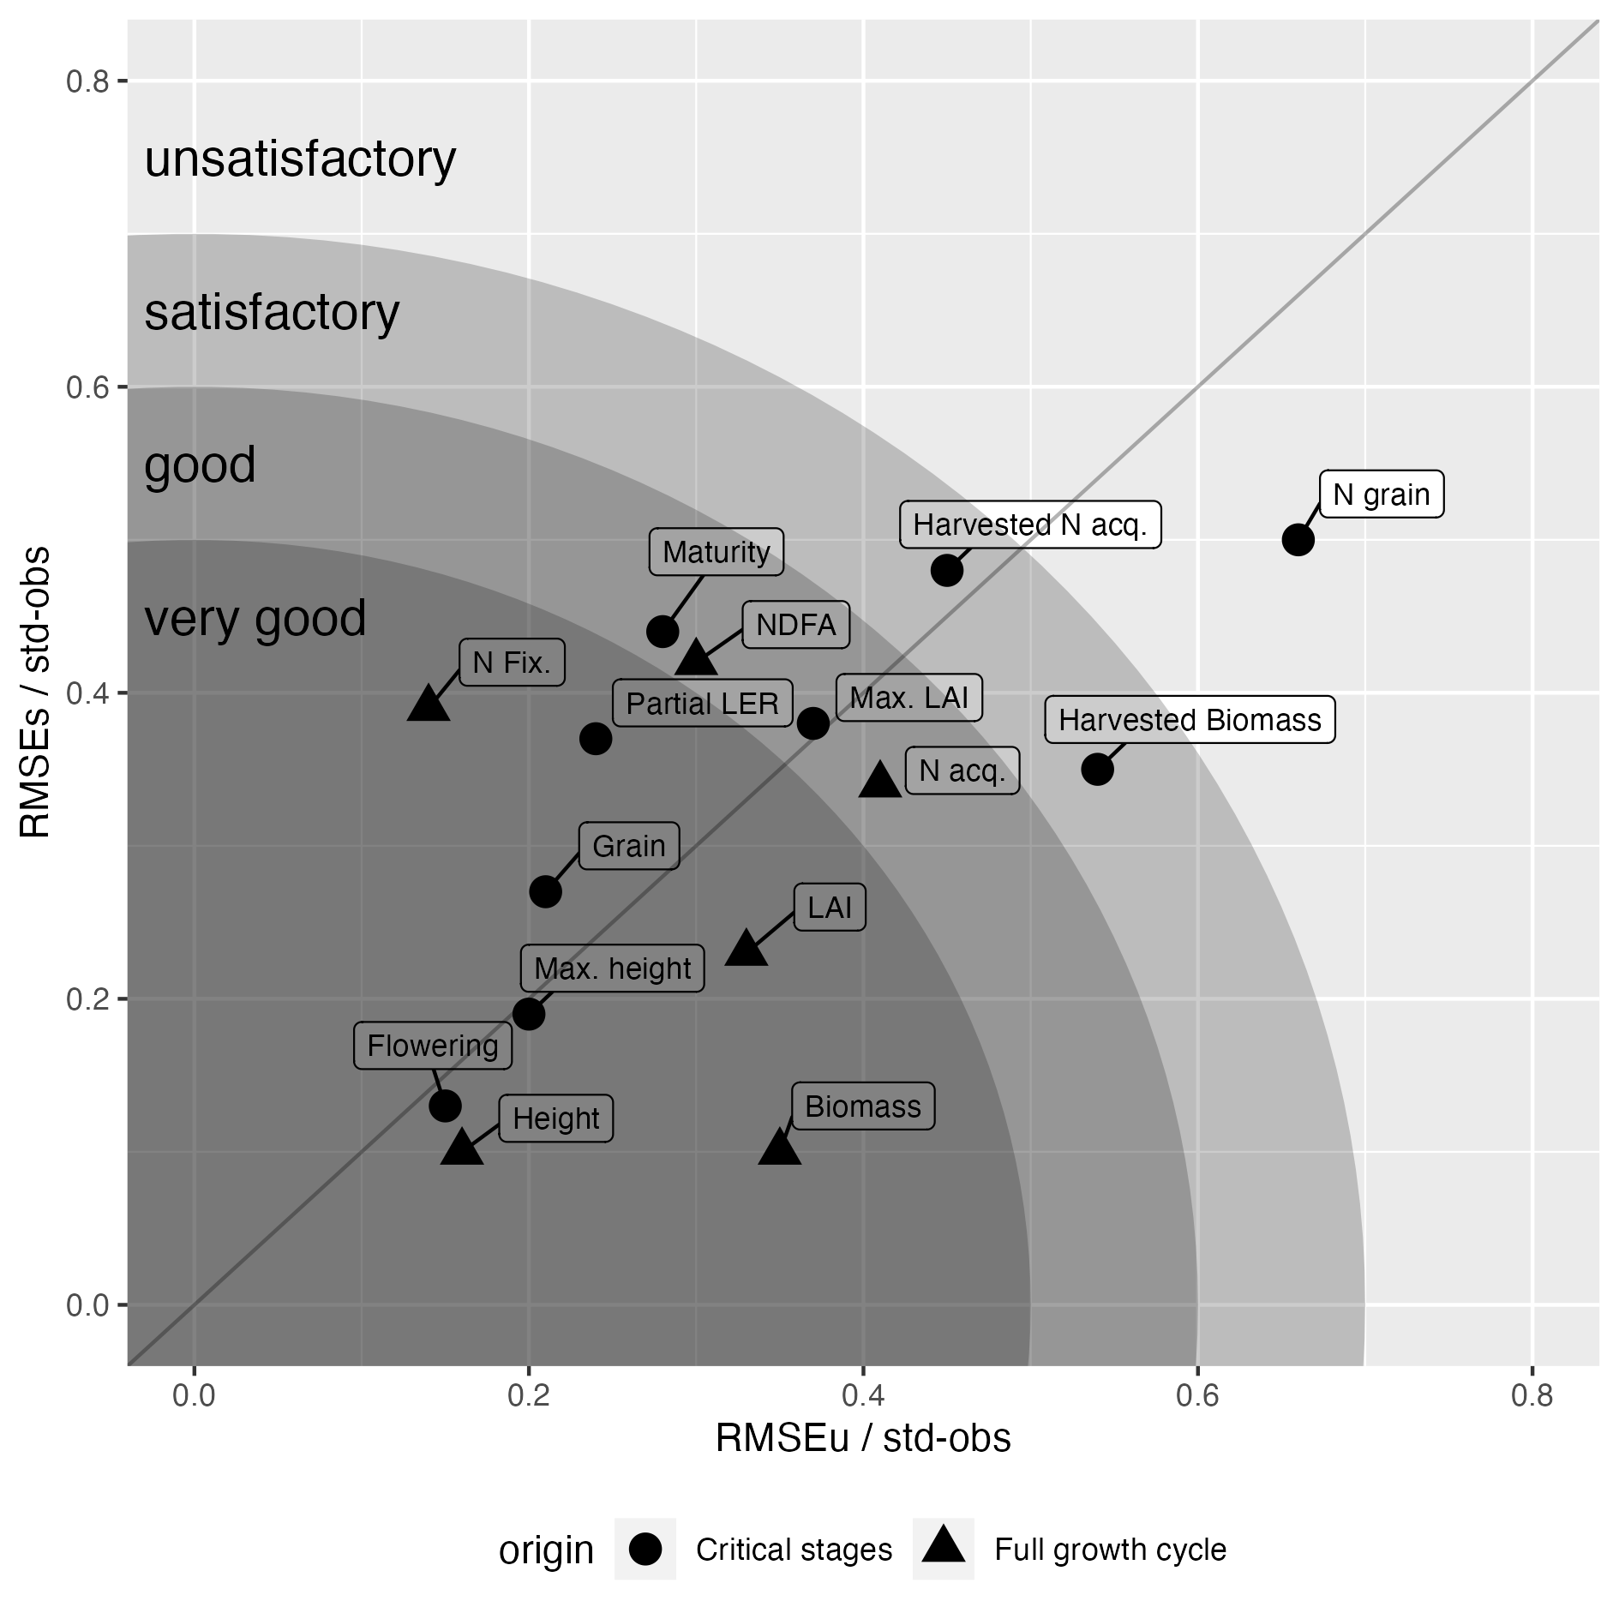

Figure A2. Synthetic graphical representation of the overall model performance based on the method proposed by Coucheney et al. (2015). Statistical indicators are shown both i) for variables measured at critical growth stages (points) and ii) over the full growth cycle (triangles). For critical stages: Julian date of flowering (Flowering), and physiological maturity (Maturity), maximum plant height (Max. height), maximum leaf area index (Max. LAI), aboveground biomass at harvest (Harvested biomass), grain yield (Grain), N acquisition in the aboveground biomass at harvest (Harvested N acq.), N content in the grains at harvest (N grain), and partial land equivalent ratio (Partial LER, crops with values above 0.5 are over-yielding). For full growth cycle: aboveground biomass (Biomass), plant height (Height), leaf area index (LAI), N acquisition in the aboveground biomass (N acq.), accumulated nitrogen from symbiotic fixation (N Fix.), and ratio of nitrogen derived from the atmosphere (NDFA) for legumes. The coordinates represent respectively the unspecific RMSE (RMSEu) and specific RMSE (RMSEs) normalized by the standard deviation of observations as proposed by Coucheney et al. (2015).

# References

Berghuijs HNC, Wang Z, Stomph TJ, et al (2020) Identification of species traits enhancing yield in wheat-faba bean intercropping: development and sensitivity analysis of a minimalist mixture model. Plant Soil 455:203–226. https://doi.org/10.1007/s11104-020-04668-0

Brisson N, Bussière F, Ozier-Lafontaine H, et al (2004) Adaptation of the crop model STICS to intercropping. Theoretical basis and parameterisation. Agronomie 24:409–421. https://doi.org/10.1051/agro:2004031

Brisson N, Gary C, Justes E, et al (2003) An overview of the crop model stics. European Journal of Agronomy 18:309–332. https://doi.org/10.1016/S1161-0301(02)00110-7

Brisson N, Launay M, Mary B, Beaudoin N (2008) Conceptual Basis, Formalisations and Parameterization of the Stics Crop Model. Editions Quae, Paris

Corre-Hellou G, Faure M, Launay M, et al (2009) Adaptation of the STICS intercrop model to simulate crop growth and N accumulation in pea–barley intercrops. Field Crops Research 113:72–81. https://doi.org/10.1016/j.fcr.2009.04.007

Coucheney E, Buis S, Launay M, et al (2015) Accuracy, robustness and behavior of the STICS soil–crop model for plant, water and nitrogen outputs: Evaluation over a wide range of agro-environmental conditions in France. Environmental Modelling & Software 64:177–190. https://doi.org/10.1016/j.envsoft.2014.11.024

Gou F, van Ittersum MK, van der Werf W (2017) Simulating potential growth in a relay-strip intercropping system: Model description, calibration and testing. Field Crops Research 200:122–142. https://doi.org/10.1016/j.fcr.2016.09.015

Justes E, Mary B, Meynard J-M, et al (1994) Determination of a critical nitrogen dilution curve for winter wheat crops. Annals of botany 74:397–407

Keating BA, Carberry PS (1993) Resource capture and use in intercropping: solar radiation. Field Crops Research 34:273–301. https://doi.org/10.1016/0378-4290(93)90118-7

Louarn G, Bedoussac L, Gaudio N, et al (2021) Plant nitrogen nutrition status in intercrops– a review of concepts and methods. European Journal of Agronomy 124:126229. https://doi.org/10.1016/j.eja.2021.126229